Ed Venator and Chris Dickey

1

|  |  |  |
| --- | --- | --- |
| Quadrant | Vgate | Igt |
| 1 | 0.394 | 0.00413 |
| 2 | -1.4 | -0.01468 |
| 3 | -1.36 | -0.01426 |
| 4 | 3.55 | 0.037212 |
|  |  |  |
|  | Vshunt | I |
| Ih | 0.07 | 0.006604 |
| Il | 0.95 | 0.089623 |

2A

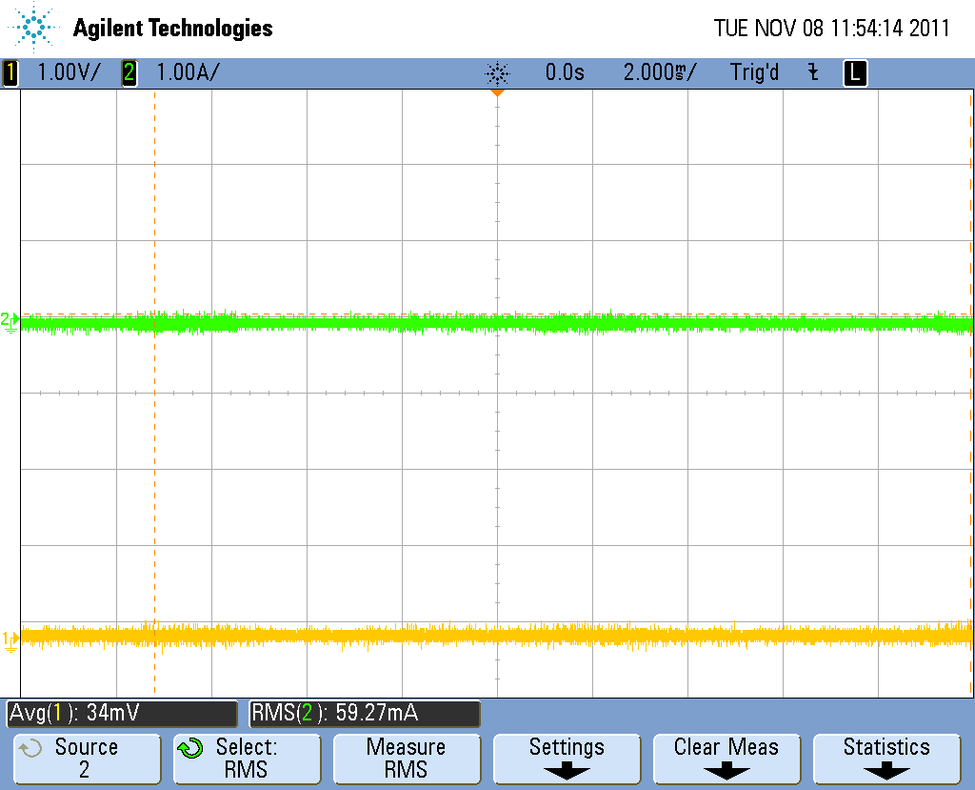

0 Input Voltage, 0 Conduction Current

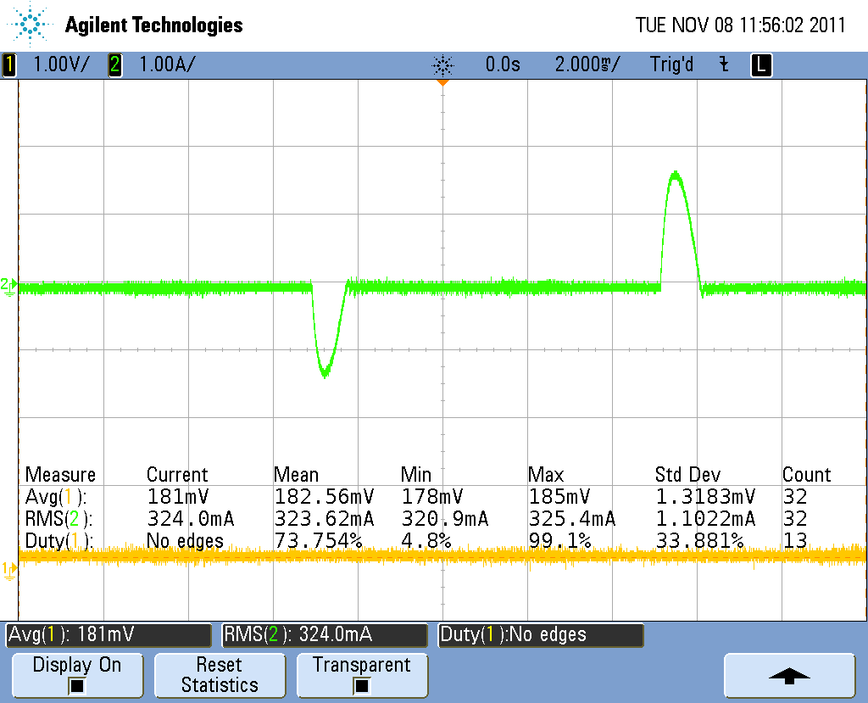

181mV input voltage, 35 deg conduction

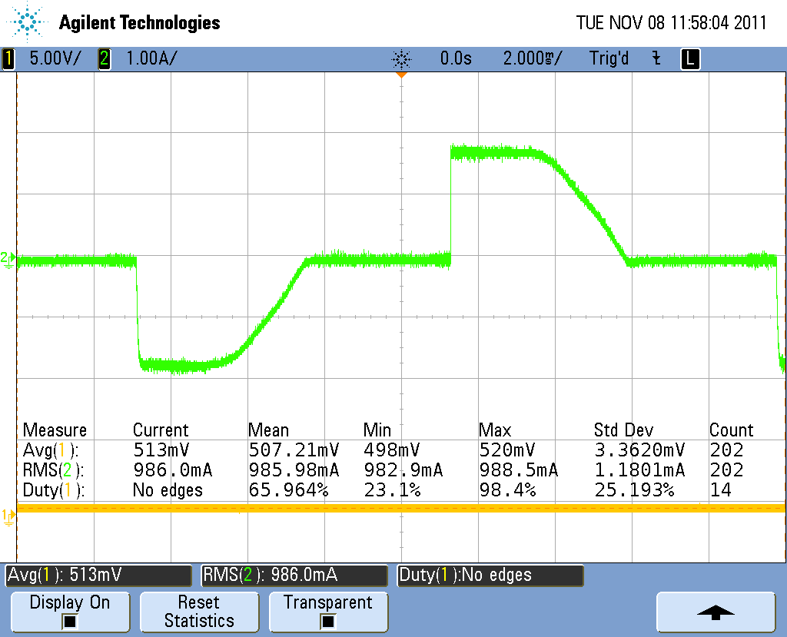

.513v input, 202 degrees conduction

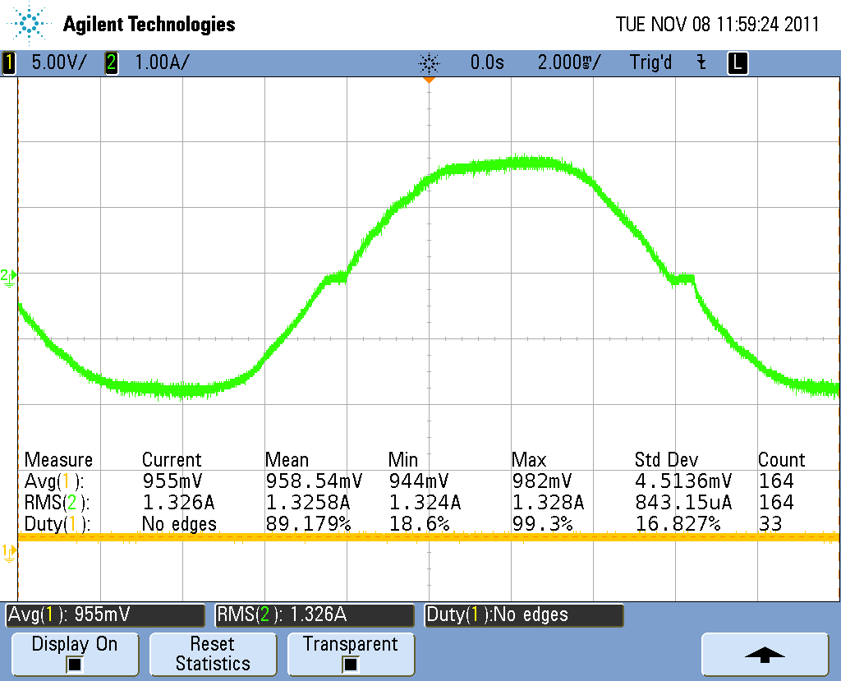

.955v input, 345 degrees of conduction

2B

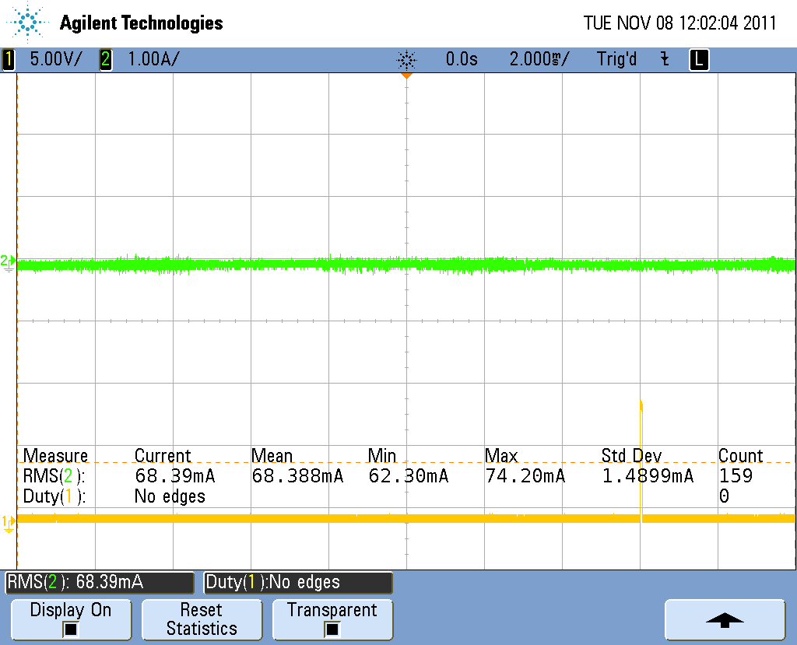

1kHz, no conduction

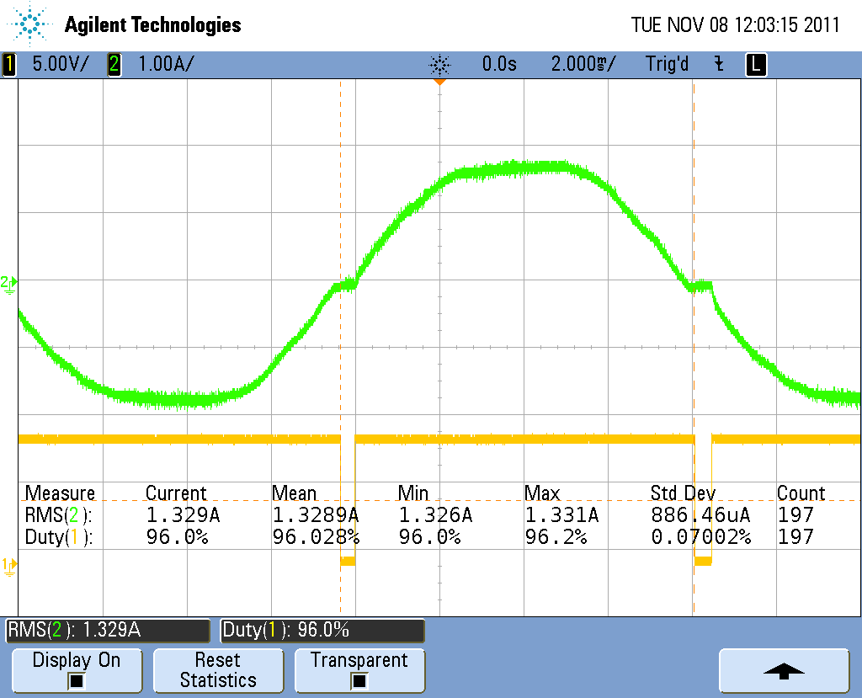

10kHz, 345 degrees conduction

Part 3

